**A**

**MINI PROJECT REPORT**

**ON**

**WORD SEARCH GAME USING UNITY**

**SUBMITTED**

**BY**

**ANAGHA S.K**

**(1601-13-737-001)**

**&**

**THEJA SHREE K**

**(1601-13-737-026)**

FOR THE PARTIAL FULLFILLMENT OF

(3/4)-B.E. INFORMATION TECHNOLOGY

UNDER THE GUIDANCE OF

**Mr. HANUMANTHARAO**

**ASSISTANT PROFESSOR**



DEPARTMENT OF INFORMATION TECHNOLOGY

CHAITANYA BHARATHI INSTITUTE OF TECHNOLOGY

**(Affiliated to Osmania University; Accredited by NBA (AICTE), ISO Certified 9001:2000)**

**Website: www.cbit.ac.in, www.cbitworld.com**

HYDERABAD – 500 075

2015-2016



**CHAITANYA BHARATHI INSTITUTE OF**

**TECHNOLOGY**

**DEPARTMENT OF INFORMATION TECHNOLOGY**

**(Affiliated to OSMANIA UNIVERSITY)**

**GANDIPET, HYDERABAD-500 075**

**CERTIFICATE**

This is to certify that the project work entitled “**WORD SEARCH GAME USING UNITY**” submitted to **CHAITANYA BHARATHI INSTITUTE OF TECHNOLOGY**, in partial fulfillment of the requirements for the award of the completion of Third year 1st semester of B.E in information technology, during the academic year 2015, is a record of original work done by **ANAGHA S.K (160113737001)** and **THEJA SHREE K.(16013737026)** during the period of study in the Dept. of IT, CBIT, HYDERABAD, under our supervision and guidance.

**PROJECT GUIDE** **HEAD OF THE DEPARTMENT**

**Mr.Hanumantharao Dr. K.Radhika**

Assistant Prof. Dept of IT. **Head of the department**

**Information Technology**

**C.B.I.T., HYDERABAD.**

**ACKNOWLEDGEMENT**

I have taken efforts in this project. However, it would not have been possible without the kind support and help of many individuals and organizations. I would like to extend my sincere thanks to all of them.

I am highly indebted to **Dr.B.Chennakeshava Rao, The Principal**,**C.B.I.T.,** Hyderabad and **Dr.K.Radhika, Head of Department, Information Technology** for their guidance and constant supervision as well as for providing necessary information regarding the project & also for their support in completing the project.

I would like to express my gratitude to our guide **Mr.Hanumantharao, Assistant Professor, Dept of IT, C.B.I.T.,** for his kind co-operation and encouragement which help me in completion of this project.

My thanks and appreciations also go to my colleague in developing the project and people who have willingly helped me out with their abilities.

**ANAGHA S.K**

**(1601-13-737-001)**

**&**

**THEJA SHREE K.**

**(1601-13-737-026)**

**DECLARATION**

We declare that the project report entitled “Word **Search Game using Unity**” is being submitted by us in the Department of Information Technology, Chaitanya Bharathi Institute of Technology, Osmania University.

This is record of bonafide work carried out by us under the guidance and supervision of **Mr.Hanumantharao, Assistant Professor,Dept of IT, C.B.I.T.**

No part of the thesis copied from books/journals/internet and wherever the portion is taken, the same has been duly referred in the text. The reported are based on the project work doing entirely by us and not copied from any other source.

**ANAGHA S.K**

**(1601-13-737-001)**

**&**

**THEJA SHREE K.**

**(1601-13-737-026)**

**ABSTRACT**

This word search game aims at using the features of the physics engine and database systems. Using the assets and scripting, a puzzle game having words arranged in a randomized manner is created. The user is expected to search for the words row-wise, column-wise, diagonally and a count of the number of words found is recorded. Also, a time limit is incorporated in the game to make it more exciting. Different levels with different topics are created. Further, a large number of puzzles in different topics along with the correct words present in them are stored using database.

**TABLE OF CONTENTS**

Acknowledgement iii

Declaration iv

Abstract v

**Contents Page No.**

1. Introduction

1.1 Purpose 1

1.2 Scope 1

1.3 Overview 3

1.4 System Analysis 4

2. Software Requirements and Specifications

2.1 Unity Physics Engine 6

2.2 MonoDevelop 8

2.3 MySQL 10

2.3.1 MySQL Workbench 12

3. Implementation 13

4. Result 19

5. Conclusion 26

6 Future Scope 27

7 Bibliography 28

**LIST OF FIGURES**

**Figure No. Page No.**

1.4.1 Loop of a Physics Engine 5

2.1.1 Logo of Unity 6

2.1.2 Unity Project 7

2.2.1 Logo of MonoDevelop 9

2.2.2Interface of MonoDevelop 9

2.3.1MySQL Workbench Interface 12

3.1Project Browser 13

3.2 Hierarchy 14

3.3 Toolbar 14

3.4 Scene View 15

3.5 Game View 15

3.6 Inspector 16

3.7 Inspector with transforms 17

4.1 Output Screenshot: Title page with names 19

4.2 Output Screenshot: Beginning Scene 19

4.3 Output Screenshot: Scene with all levels 20

4.4 Output Screenshot: Colors grid 20

4.5 Output Screenshot: Gemstones grid 21

4.6 Output Screenshot: Motorcars grid 21

4.7Output Screenshot: Computer grid 22

4.8 Output Screenshot: Paused scene 22

4.9 Output Screenshot: End of the game scene 23

4.10 Output Screenshot: Scene view and Game view 23

4.11 Output Screenshot: Foam in the background 24

4.12 Output Screenshot: Script of Unity to database connection 24

4.13 Output Screenshot: Script implementing timer 25

4.14 Output Screenshot: Fig showing dll files 25

**1. INTRODUCTION**

**1.1 Purpose**

Playing and solving puzzles on a regular basis has many educational benefits. There are so many positives about playing these games. It helps to b**oost your vocabulary. Puzzles are great for improving your spelling and logic skills. Playing puzzles help you improve your problem solving skills. It** h**elps kids learn with games-based learning.** Puzzles offer portable and inexpensive entertainment, a way to keep you mentally active and fit. Helps improve word power and vocabulary, and is a painless spelling practice.

Games development using web development techniques and Java Script or Java is quite complex and a tedious task. Moreover, even after developing them, it is almost impossible to design the levels and link them together. High end games are impossible to code using traditional programming techniques. So, in this project, we would like to portray how games are actually programmed using a Physics Engine which is actually more or less a simulation of the real world.

**1.2 Scope**

This project, essentially a game uses a database connection which is unusual. Such techniques are used for MMO simulation. That is for massive multiplayer online games where many players can play in the same game space. It requires optimised and correct and safe usage of database to store the players and to let them simulate in the game and play at their will. And since we use Physics Engine, the scope of expansion to different platforms (Android, iOS, pc, web, blackberry, PS3, PS4, PS5 literally any platform) is very high.

So, scope of 'using physics engine' is that it is reliable and can be easily compatible and convertible to platforms and also physics engine makes it more REALISTIC. That’s what modern games are all about!

Some MMOGs have been designed to accurately simulate certain aspects of the real world. They tend to be very specific to industries or activities of very large risk and huge potential loss, such as rocket science, airplanes, trucks, battle tanks, submarines etc. Gradually as simulation technology is getting more mainstream, so too various simulators arrive into more mundane industries. The initial goal of [*World War II Online*](https://en.wikipedia.org/wiki/World_War_II_Online) was to create a map (in north Western Europe) that had real world physics (gravity, air/water resistance, etc.), and ability for players to have some strategic abilities to its basic FPS/RPG role.

While the current version is not quite a true simulated world, it is very complex and contains a large persistent world. The MMOG genre of air traffic simulation is one example, with networks such as [VATSIM](https://en.wikipedia.org/wiki/VATSIM) and [IVAO](https://en.wikipedia.org/wiki/International_Virtual_Aviation_Organization) striving to provide rigorously authentic [flight-simulation](https://en.wikipedia.org/wiki/Flight_simulation) environments to players in both pilot and air traffic controller roles. In this category of MMOGs, the objective is to create duplicates of the real world for people who cannot or do not wish to undertake those experiences in real life. For example, flight simulation via an MMOG requires far less expenditure of time and money, is completely risk-free, and is far less restrictive (fewer regulations to adhere to, no medical exams to pass, and so on).

Another specialist area is mobile telecoms operator (carrier) business where billion-dollar investments in networks are needed but market shares are won and lost on issues from segmentation to handset subsidies. A specialist simulation was developed by Nokia called Equilibrium/Arbitrage to have over a two-day period five teams of top management of one operator/carrier play a "war-game" against each other, under extremely realistic conditions, with one operator an incumbent fixed and mobile network operator, another a new entrant mobile operator, a third a fixed-line/internet operator etc. Each team is measured by outperforming their rivals by market expectations of that type of player. Thus each player has drastically different goals, but within the simulation, any one team can win. Also to ensure maximum intensity, only one team can win. Telecoms senior executives who have taken the Equilibrium/Arbitrage simulation say it is the most intense and most useful training they have ever experienced. It is typical of business use of simulators, in very senior management training/retraining.

However, to introduce that concept, this game simply has words in the database which is retrieved using an ODBC connection.

And lastly, in simple terms, Database has too much scope in game development. Game programmers essentially use many forms of relation databases at run-time to store and organize things like game objects and various resources. Databases are run by a server, so the first thing you need to do is set up a server. The server can be local, in that it’s part of your code, and you access it directly via a relatively low level API. Alternatively the server can be remote, and you access it via a network connection.

**1.3 Overview**

Development and design studios, multinational corporations and government organizations all use the Unity game development engine. They are creating successful and award-winning 3D content for military simulation, medical training, virtual reality, architecture, advertising and retail. Unity’s complete toolset, intuitive workspace, productive workflows, and Community help users to drastically reduce the time, effort and cost of making professional games and 3D content. Key Unity benefits include:

* **Rapid Production:** A smooth asset pipeline and fast scene building; on-the-fly play testing and editing; efficient optimization of performance, and one click access to the Community, Documentation and the Asset Store keep your game making highly productive.
* **Cinematic Graphics And Sound**: Transform your game into a refined, polished product with high-quality, high-performing lighting options, post-processing special effects and particle systems; audio filters for resonant scenes, and render-to-texture effects for extra nuance and realism.
* **Real time Networking**: Unity makes real time networking easy. With just a few changes to your existing code, you can turn a single-user scenario into a networked multiplayer virtual world. When running in a web browser, the deployed Unity Web Player seamlessly communicates with the container web page. The Unity Web Player has received certification to be installed on secure networks for the US Army and US Air Force.
* **Performance Optimization**: Unity delivers smooth framerate and superb game play experiences across target platforms. Optimize game play every step of the way with the Unity Profiler, while platform-specific run- and build time optimizations ensure a smooth-running application.
* **Multiplatform Publishing**: Unity gives you the freedom to target multiple platforms from a single project. When your game is ready, you simply select “Build & Run” from the drop-down menu. Choose your platform and relax while your application automatically compiles, installs and launches.

**1.4 System Analysis**

**Kinematics**: The branch of mechanics concerned with the motion of objects without reference to the forces which cause the motion.

**Rigid body**: A rigid body is an idealization of a solid body in which deformation is neglected. In other words, the distance between any two given points of a rigid body remains constant in time regardless of external forces exerted on it.

Initially many tests are carried out on the physics Engine Unity. It uses gravity tools, hence when an object is dropped in the game space, the object actually falls off with a speed of 9.8m/s. The rigid body will be under full control of animation or script control by changing position. Kinematic bodies also affect the motion of other rigid bodies through collisions or joints.

Eg: It can connect a kinematic rigid body to a normal rigid body with a joint and the rigid body will be constrained with the motion of the kinematic body. Kinematic rigid bodies are also particularly useful for making characters which are normally driven by an animation, but on certain events can be quickly turned into a ragdoll by setting isKinematic(a Boolean) to false.

Next, the advantages of using Unity over normal Java is listed out. It is seen that using Unity helps in,

* Better Modularity of code for different objects
* Flexible and easy Designing
* Already available design templates
* Kinematics
* Better packaging of all the levels
* Flexibility of programming languages used
* Easy Debugging
* Professional Game Development.

Here is the process of how the Unity Engine evaluates the code: automata of how the code runs when the user interacts.

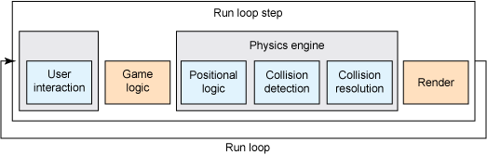

Fig 1.4.1 Loop of a Physics Engine

**2. SOFTWARE REQUIREMENTS AND SPECIFICATIONS**

**2.1 Unity Physics Engine**

**Unity** is a [cross-platform](https://en.wikipedia.org/wiki/Cross-platform) [game engine](https://en.wikipedia.org/wiki/Game_engine) developed by [Unity Technologies](https://en.wikipedia.org/wiki/Unity_Technologies) and used to develop [video games](https://en.wikipedia.org/wiki/Video_game) for [PC](https://en.wikipedia.org/wiki/Personal_computer), [consoles](https://en.wikipedia.org/wiki/Video_game_console), [mobile devices](https://en.wikipedia.org/wiki/Mobile_device) and [websites](https://en.wikipedia.org/wiki/Website). First announced only for [OS X](https://en.wikipedia.org/wiki/OS_X), at Apple’s Worldwide Developers Conference in 2005, it has since been extended to target more than fifteen platforms. It is now the default [software development kit](https://en.wikipedia.org/wiki/Software_development_kit) (SDK) for the [Wii U](https://en.wikipedia.org/wiki/Wii_U). On March 3, 2015 with the release of Unity 5.0, Unity Technologies made the complete engine available for free including all features, less source code and premium support. Unity is noted for an ability to target games to multiple platforms.



Fig 2.1.1 Logo of Unity

With an emphasis on portability, the engine targets the following APIs: [Direct3D](https://en.wikipedia.org/wiki/Microsoft_Direct3D) on Windows and Xbox 360; [OpenGL](https://en.wikipedia.org/wiki/OpenGL) on Mac and Windows; [OpenGL ES](https://en.wikipedia.org/wiki/OpenGL_ES) on Android and iOS; and proprietary APIs on [video game consoles](https://en.wikipedia.org/wiki/Video_game_console). Unity allows specification of [texture compression](https://en.wikipedia.org/wiki/Texture_compression) and resolution settings for each platform the game engine supports, and provides support for [bump mapping](https://en.wikipedia.org/wiki/Bump_mapping), [reflection mapping](https://en.wikipedia.org/wiki/Reflection_mapping), [parallax mapping](https://en.wikipedia.org/wiki/Parallax_mapping), [screen space ambient occlusion](https://en.wikipedia.org/wiki/Screen_space_ambient_occlusion) (SSAO), dynamic shadows using[shadow maps](https://en.wikipedia.org/wiki/Shadow_map), [render-to-texture](https://en.wikipedia.org/wiki/Render_to_Texture) and full-screen post-processing effects. Unity's graphics engine's platform diversity can provide a shader with multiple variants and a declarative fallback specification, allowing Unity to detect the best variant for the current video hardware; and if none are compatible, fall back to an alternative shader that may sacrifice features for performance.

The game engine's scripting is built on [Mono](https://en.wikipedia.org/wiki/Mono_(software)), the open-source implementation of the [.NET Framework](https://en.wikipedia.org/wiki/.NET_Framework). Programmers can use UnityScript (a custom language with [ECMAScript](https://en.wikipedia.org/wiki/ECMAScript)-inspired syntax, referred to as [JavaScript](https://en.wikipedia.org/wiki/JavaScript) by the software), [C#](https://en.wikipedia.org/wiki/C_Sharp_(programming_language)), or [Boo](https://en.wikipedia.org/wiki/Boo_(programming_language)) (which has a [Python](https://en.wikipedia.org/wiki/Python_(programming_language))-inspired syntax).

Unity is notable for its ability to target games to multiple platforms. Within a project, developers have control over delivery to mobile devices, web browsers, desktops, and consoles. Supported platforms include [BlackBerry 10](https://en.wikipedia.org/wiki/BlackBerry_10), [Windows Phone 8](https://en.wikipedia.org/wiki/Windows_Phone_8), [Windows](https://en.wikipedia.org/wiki/Microsoft_Windows), [OS X](https://en.wikipedia.org/wiki/OS_X), [Android](https://en.wikipedia.org/wiki/Android_(operating_system)), [iOS](https://en.wikipedia.org/wiki/IOS), Unity Web Player (including Facebook), [PlayStation 3](https://en.wikipedia.org/wiki/PlayStation_3), [PlayStation 4](https://en.wikipedia.org/wiki/PlayStation_4), [PlayStation Vita](https://en.wikipedia.org/wiki/PlayStation_Vita), [Xbox 360](https://en.wikipedia.org/wiki/Xbox_360), [Xbox One](https://en.wikipedia.org/wiki/Xbox_One), [Wii U](https://en.wikipedia.org/wiki/Wii_U), [Nintendo 3DS line](https://en.wikipedia.org/wiki/Nintendo_3DS_line) and [Wii](https://en.wikipedia.org/wiki/Wii). It includes an asset server and [Nvidia's](https://en.wikipedia.org/wiki/Nvidia)[PhysX](https://en.wikipedia.org/wiki/PhysX) physics engine. Unity Web Player is a browser plugin that issupported in Windows and OS X only. Unity is the default [software development kit](https://en.wikipedia.org/wiki/Software_development_kit) (SDK) for Nintendo's [Wii U](https://en.wikipedia.org/wiki/Wii_U) [video game console](https://en.wikipedia.org/wiki/Video_game_console) platform, with a free copy included by Nintendo with each Wii U developer license. Unity Technologies calls this bundling of a third-party SDK an "industry first". Unity 5.0 was released for free on March 3, 2015, adding the much anticipated real-time [global illumination](https://en.wikipedia.org/wiki/Global_illumination) based on the Geomerics Enlighten technology. Other major changes include physically-based [shaders](https://en.wikipedia.org/wiki/Shaders), [HDR](https://en.wikipedia.org/wiki/High-dynamic-range_rendering) sky-boxes, reflection probes, a new [audio mixer](https://en.wikipedia.org/wiki/Audio_mixer) with effects and enhanced animator workflows.

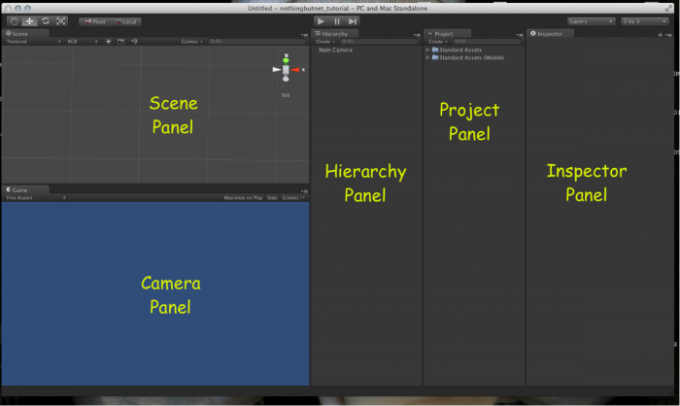

Fig 2.1.2 Window showing various parts in a Unity project

Unity's Cloud Build system was introduced (for $25/month for non-pro users) as well as 'Game Performance Reporting' and the beta 'Game Analytics' (also $25/month for non-pro users) which logs players usage and performance on released games, something that many developers found hard to implement in Unity 4.x. Previously, a game developer needed to code support for player logging directly into their [game engine](https://en.wikipedia.org/wiki/Game_engine). Smaller additions include: A [64-bit](https://en.wikipedia.org/wiki/64-bit_computing) editor to handle large projects, iOS 64-bit support, new deferred rendering, graphics command buffers, improved linear lighting, HDR, [skybox](https://en.wikipedia.org/wiki/Skybox_(video_games)) and [cubemap](https://en.wikipedia.org/wiki/Cubemap) workflows, improved job scheduling system, a new 'CPU Timeline Profiler' lets you see and investigate multi core usage, improved NavMesh [pathfinding](https://en.wikipedia.org/wiki/Pathfinding) system.

Up until Unity 5.0 the engine was using a fairly outdated version of Nvidia's [PhysX](https://en.wikipedia.org/wiki/PhysX) physics middleware. Unity 5.0 included version 3.3, which is standard among Triple-A games. Unity 5.0 brings support for [Windows](https://en.wikipedia.org/wiki/Windows_(operating_system)), [OS X](https://en.wikipedia.org/wiki/OS_X), Unity Webplayer, [Android](https://en.wikipedia.org/wiki/Android_(operating_system)), [iOS](https://en.wikipedia.org/wiki/IOS), [BlackBerry 10](https://en.wikipedia.org/wiki/BlackBerry_10), [Windows Phone 8](https://en.wikipedia.org/wiki/Windows_Phone_8), [Tizen](https://en.wikipedia.org/wiki/Tizen), [WebGL](https://en.wikipedia.org/wiki/WebGL), [PlayStation 3](https://en.wikipedia.org/wiki/PlayStation_3), [PlayStation 4](https://en.wikipedia.org/wiki/PlayStation_4),[PlayStation Vita](https://en.wikipedia.org/wiki/PlayStation_Vita), [Wii U](https://en.wikipedia.org/wiki/Wii_U), [Nintendo 3DS line](https://en.wikipedia.org/wiki/Nintendo_3DS_line), [Xbox 360](https://en.wikipedia.org/wiki/Xbox_360), [Xbox One](https://en.wikipedia.org/wiki/Xbox_One), [Android TV](https://en.wikipedia.org/wiki/Android_TV), [Samsung Smart TV](https://en.wikipedia.org/wiki/Samsung_Smart_TV), [Oculus Rift](https://en.wikipedia.org/wiki/Oculus_Rift), [HTC Vive](https://en.wikipedia.org/wiki/HTC_Vive)and [Gear VR](https://en.wikipedia.org/wiki/Gear_VR).

On August 26, 2015 an experimental version was released for Ubuntu Linux with an unofficial platform-agnostic installer for most modern 64 bit Linux versions, and official support only for 64-bit Ubuntu 12.04 or newer.

**2.2 MonoDevelop**

**MonoDevelop** is an [open source](https://en.wikipedia.org/wiki/Open_source) [integrated development environment](https://en.wikipedia.org/wiki/Integrated_development_environment) for [Linux](https://en.wikipedia.org/wiki/Linux), [OS X](https://en.wikipedia.org/wiki/OS_X), and [Windows](https://en.wikipedia.org/wiki/Windows). Its primary focus is development of projects that use [Mono](https://en.wikipedia.org/wiki/Mono_(software)) and [.NET frameworks](https://en.wikipedia.org/wiki/.NET_framework). MonoDevelop integrates features similar to those of [NetBeans](https://en.wikipedia.org/wiki/NetBeans) and [Microsoft Visual Studio](https://en.wikipedia.org/wiki/Microsoft_Visual_Studio), such as [automatic code completion](https://en.wikipedia.org/wiki/Autocomplete), [source control](https://en.wikipedia.org/wiki/Revision_control), a [graphical user interface](https://en.wikipedia.org/wiki/Graphical_user_interface) (GUI) and [Web designer](https://en.wikipedia.org/wiki/HTML_editor). MonoDevelop integrates a [Gtk#](https://en.wikipedia.org/wiki/Gtk_Sharp) GUI designer called[Stetic](https://en.wikipedia.org/wiki/MonoDevelop#Stetic). It supports [Boo](https://en.wikipedia.org/wiki/Boo_(programming_language)), [C](https://en.wikipedia.org/wiki/C_(programming_language)), [C++](https://en.wikipedia.org/wiki/C%2B%2B), [C#](https://en.wikipedia.org/wiki/C_Sharp_(programming_language)), [CIL](https://en.wikipedia.org/wiki/Common_Intermediate_Language), [D](https://en.wikipedia.org/wiki/D_(programming_language)), [F#](https://en.wikipedia.org/wiki/F_Sharp_(programming_language)), [Java](https://en.wikipedia.org/wiki/Java_(programming_language)), [Oxygene](https://en.wikipedia.org/wiki/Oxygene_(programming_language)), [Python](https://en.wikipedia.org/wiki/Python_(programming_language)), [Vala](https://en.wikipedia.org/wiki/Vala_(programming_language)), and [Visual Basic.NET](https://en.wikipedia.org/wiki/Visual_Basic.NET).

MonoDevelop can be used on [Windows](https://en.wikipedia.org/wiki/Windows), [OS X](https://en.wikipedia.org/wiki/OS_X) and [Linux](https://en.wikipedia.org/wiki/Linux). The first two have been officially supported since version 2.2. [Xamarin](https://en.wikipedia.org/wiki/Xamarin) offers a rebranded version of MonoDevelop 4.0 as Xamarin Studio which now uses platform-specific code in various places to enhance the look and feel. While Mono provides a package for [Solaris](https://en.wikipedia.org/wiki/Solaris_(operating_system)) 10 running on [SPARC](https://en.wikipedia.org/wiki/SPARC), MonoDevelop packages for [Open Solaris](https://en.wikipedia.org/wiki/OpenSolaris) are only provided by groups from the OpenSolaris community. MonoDevelop on [FreeBSD](https://en.wikipedia.org/wiki/FreeBSD) is likewise supported only by the FreeBSD community.



Fig 2.2.1 Logo of MonoDevelop

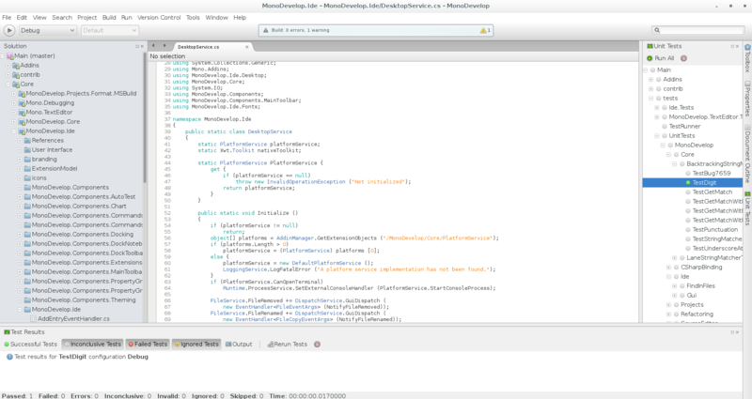

Fig 2.2.2MonoDevelop Interface

**2.3 MySQL**

**MySQL** is an [open-source](https://en.wikipedia.org/wiki/Open-source) [relational database management system](https://en.wikipedia.org/wiki/Relational_database_management_system) (RDBMS); and the most widely used open-source [client–server model](https://en.wikipedia.org/wiki/Client%E2%80%93server_model) RDBMS. The [SQL](https://en.wikipedia.org/wiki/SQL) acronym stands for [Structured Query Language](https://en.wikipedia.org/wiki/Structured_Query_Language). The MySQL development project has made its [source code](https://en.wikipedia.org/wiki/Source_code) available under the terms of the [GNU General Public License](https://en.wikipedia.org/wiki/GNU_General_Public_License), as well as under a variety of [proprietary](https://en.wikipedia.org/wiki/Proprietary_software) agreements.

MySQL is a popular choice of database for use in web applications, and is a central component of the widely used [LAMP](https://en.wikipedia.org/wiki/LAMP_(software_bundle)) open source web application software stack (and other "[AMP](https://en.wikipedia.org/wiki/List_of_AMP_packages)" stacks). LAMP is an acronym for "[Linux](https://en.wikipedia.org/wiki/Linux), [Apache](https://en.wikipedia.org/wiki/Apache_HTTP_Server), MySQL, [Perl](https://en.wikipedia.org/wiki/Perl)/[PHP](https://en.wikipedia.org/wiki/PHP)/[Python](https://en.wikipedia.org/wiki/Python_(programming_language))." [Free-software](https://en.wikipedia.org/wiki/Free_software)-open source projects that require a full-featured database management system often use MySQL. Applications that use the MySQL database include: [TYPO3](https://en.wikipedia.org/wiki/TYPO3),[MODx](https://en.wikipedia.org/wiki/MODx), [Joomla](https://en.wikipedia.org/wiki/Joomla), [WordPress](https://en.wikipedia.org/wiki/WordPress), [phpBB](https://en.wikipedia.org/wiki/PhpBB), [MyBB](https://en.wikipedia.org/wiki/MyBB), [Drupal](https://en.wikipedia.org/wiki/Drupal) and other software. MySQL is also used in many high-profile, large-scale [websites](https://en.wikipedia.org/wiki/Website), including Google, Facebook, Twitter, Flickr and You tube.

On all platforms except Windows, MySQL ships with no [GUI](https://en.wikipedia.org/wiki/Graphical_user_interface) tools to administer MySQL databases or manage data contained within the databases. Users may use the included [command line](https://en.wikipedia.org/wiki/Command_line) tools, or install [MySQL Workbench](http://dev.mysql.com/downloads/workbench/) via a separate download. Many third party GUI tools are also available.

MySQL is offered under two different editions: the open source MySQL Community Server and the proprietary [Enterprise Server](https://en.wikipedia.org/wiki/MySQL_Enterprise). MySQL Enterprise Server is differentiated by a series of proprietary extensions which install as server plugins, but otherwise shares the version numbering system and is built from the same code base.

Major features as available in MySQL 5.6:

* A broad subset of [ANSI SQL 99](https://en.wikipedia.org/wiki/SQL:1999), as well as extensions
* Cross-platform support
* [Stored procedures](https://en.wikipedia.org/wiki/Stored_procedure), using a procedural language that closely adheres to [SQL/PSM](https://en.wikipedia.org/wiki/SQL/PSM)
* [Triggers](https://en.wikipedia.org/wiki/Database_trigger)
* [Cursors](https://en.wikipedia.org/wiki/Cursor_(databases))
* Updatable [views](https://en.wikipedia.org/wiki/View_(SQL))
* [Online DDL](https://en.wikipedia.org/wiki/Data_Definition_Language) when using the InnoDB Storage Engine.
* [Information schema](https://en.wikipedia.org/wiki/Information_schema)
* Performance Schema
* A set of SQL Mode options to control runtime behavior, including a strict mode to better adhere to SQL standards.
* [X/Open XA](https://en.wikipedia.org/wiki/X/Open_XA) [distributed transaction processing](https://en.wikipedia.org/wiki/Distributed_transaction_processing) (DTP) support; [two phase commit](https://en.wikipedia.org/wiki/Two-phase-commit_protocol) as part of this, using the default [InnoDB](https://en.wikipedia.org/wiki/InnoDB) storage engine
* Transactions with [savepoints](https://en.wikipedia.org/wiki/Savepoint) when using the default InnoDB Storage Engine. The NDB Cluster Storage Engine also supports transactions.
* [ACID](https://en.wikipedia.org/wiki/Atomicity,_consistency,_isolation,_durability) compliance when using InnoDB and NDB Cluster Storage Engines
* [SSL](https://en.wikipedia.org/wiki/Secure_Sockets_Layer) support
* Query [caching](https://en.wikipedia.org/wiki/Cache_(computing))
* Sub-[SELECTs](https://en.wikipedia.org/wiki/Select_(SQL)) (i.e. nested SELECTs)
* Built-in [Replication](https://en.wikipedia.org/wiki/Database_replication) support (i.e. Master-Master Replication & Master-Slave Replication) with one master per slave, many slaves per master. [Multi-master replication](https://en.wikipedia.org/wiki/Multi-master_replication) is provided
* in [MySQL Cluster](https://en.wikipedia.org/wiki/MySQL_Cluster), and multi-master support can be added to unclustered configurations using Galera Cluster.
* Full-text [indexing](https://en.wikipedia.org/wiki/Index_(database)) and searching
* Embedded database library
* [Unicode](https://en.wikipedia.org/wiki/Unicode) support
* Partitioned tables with pruning of partitions in optimizer
* [Shared-nothing](https://en.wikipedia.org/wiki/Shared-nothing) clustering through [MySQL Cluster](https://en.wikipedia.org/wiki/MySQL_Cluster)
* Multiple storage engines, allowing one to choose the one that is most effective for each table in the application.
* Native storage engines [InnoDB](https://en.wikipedia.org/wiki/InnoDB), [MyISAM](https://en.wikipedia.org/wiki/MyISAM), Merge, Memory (heap), [Federated](https://en.wikipedia.org/wiki/MySQL_Federated), Archive, [CSV](https://en.wikipedia.org/wiki/Comma-separated_values), Blackhole, NDB Cluster.
* Commit grouping, gathering multiple transactions from multiple connections together to increase the number of commits per second.

**2.3.1 MySQL Workbench**

[MySQL Workbench](https://en.wikipedia.org/wiki/MySQL_Workbench) is the official integrated environment for MySQL. It was developed by MySQL AB, and enables users to graphically administer MySQL databases and visually design database structures. MySQL Workbench replaces the previous package of software, [MySQL GUI Tools](https://en.wikipedia.org/wiki/MySQL_GUI_Tools). Similar to other third-party packages, but still considered the authoritative MySQL front end, MySQL Workbench lets users manage database design & modeling, SQL development (replacing MySQL Query Browser) and Database administration (replacing MySQL Administrator).

MySQL Workbench is available in two editions, the regular [free and open source](https://en.wikipedia.org/wiki/Free_and_open_source_software) *Community*

*Edition* which may be downloaded from the MySQL website, and the proprietary *Standard Edition* which extends and improves the feature set of the Community Edition.

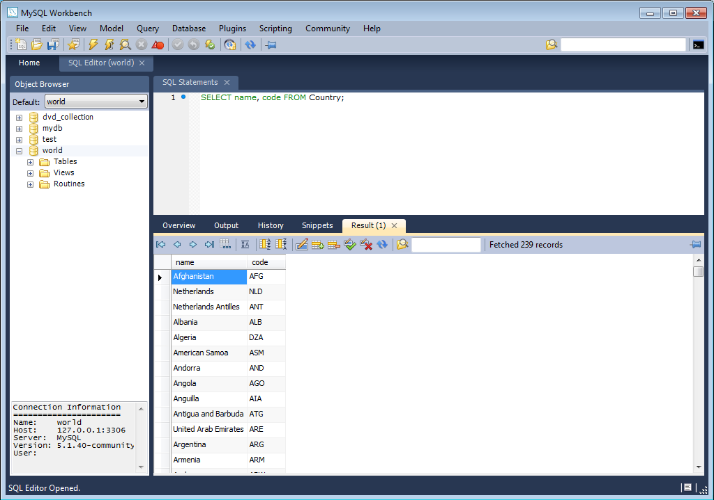

Fig 2.3.1 MySQL Workbench Interface

**3. IMPLEMENTATION**

Unity is a feature rich, fully integrated development engine that provides out-of-the-box functionality for the creation of interactive 3D content. Unity’s complete toolset, intuitive workspace, productive workflows, and Community help users to drastically reduce the time, effort and cost of making professional games and 3D content.

We use Unity to assemble art and assets into scenes and environments; add physics, light, video, audio and post-processing special effects; play test, edit and optimize your game, and when ready, publish to your chosen platforms, such as desktop computers, web browsers, iPhone, iPad, Android, Kinect and CAVE's.

The main editor window is made up of several tabbed panels known in Unity as Views. There are several types of Views in Unity –

# Project Browser

In this view, you can access and manage the assets that belong to your project.

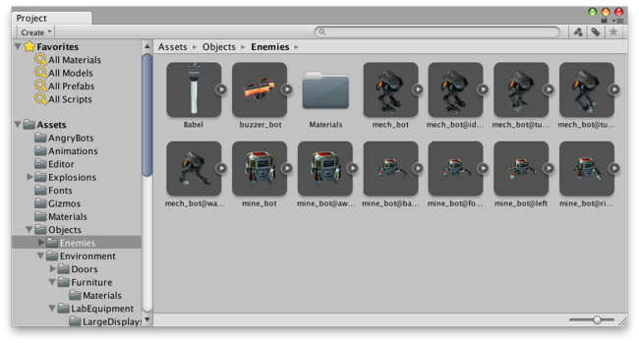

Fig 3.1 Project Browser

The left panel of the browser shows the folder structure of the project as a hierarchical list. When a folder is selected from the list by clicking, its contents will be shown in the panel to the right. You can click the small triangle to expand or collapse the folder, displaying any nested folders it contains. Hold down Alt while you click to expand or collapse any nested folders recursively.

The individual assets are shown in the right hand panel as icons that indicate their type (script, material, sub-folder, etc). The icons can be resized using the slider at the bottom of the panel; they will be replaced by a hierarchical list view if the slider is moved to the extreme left. The space to the left of the slider shows the currently selected item, including a full path to the item if a search is being performed.

# Hierarchy

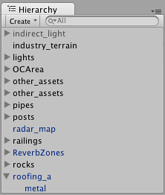

Fig 3.2 Example Hierarchy

The Hierarchy contains every GameObject in the current Scene. Some of these are direct instances of asset files like 3D models, and others are instances of [Prefabs](http://docs.unity3d.com/Manual/Prefabs.html), custom objects that will make up much of your game. You can select objects in the Hierarchy and drag one object onto another to make use of Parenting. As objects are added and removed in the scene, they will appear and disappear from the Hierarchy as well. By default the GameObjects will be listed in the Hierarchy window in the order they are made. It is possible to re-order the GameObjects by dragging them up or down, or making them children or parents.

# Toolbar

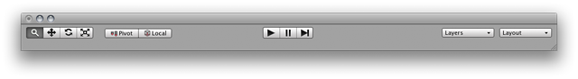

Fig 3.3 Toolbar

The Toolbar consists of five basic controls. Each relate to different parts of the Editor.

Transform Tools – used with the Scene View  
 Transform Gizmo Toggles – affect the Scene View display  
 Play/Pause/Step Buttons – used with the Game View  
 [Layers](http://docs.unity3d.com/Manual/Layers.html) Drop-down – controls which objects are displayed in Scene View  
 Layout Drop-down – controls arrangement of all View.

# Scene View

The Scene View is your interactive sandbox. You will use the Scene View to select and position environments, the player, the camera, enemies, and all other GameObjects. Maneuvering and manipulating objects within the Scene View are some of the most important functions in Unity, so it’s important to be able to do them quickly. To this end, Unity provides keystrokes for the most common operations.

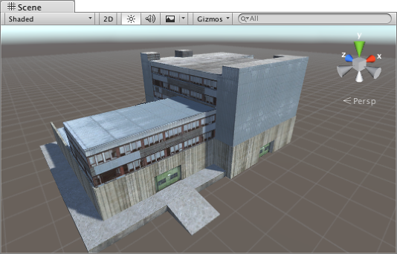

Fig 3.4 Example of a scene view

# Game View

The Game View is rendered from the Camera(s) in your game. It is representative of your final, published game. You will need to use one or more Cameras to control what the player actually sees when they are playing your game.

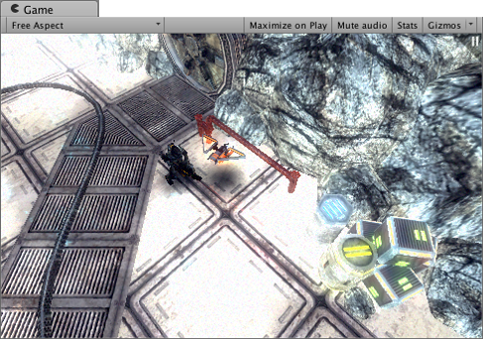

Fig 3,5 Example of game view

**Inspector**

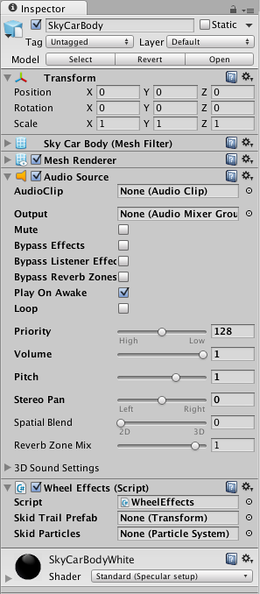

Fig 3.6 Inspector

Games in Unity are made up of multiple GameObjects that contain meshes, scripts, sounds, or other graphical elements like Lights. The Inspector displays detailed information about your currently selected Game Object, including all attached Components and their properties. Here, you modify the functionality of Game Objects in your scene. You can read more about the [GameObject-Component relationship](http://docs.unity3d.com/Manual/GameObjects.html), as it is very important to understand. Any property that is displayed in the Inspector can be directly modified. Even script variables can be

changed without modifying the script itself. You can use the Inspector to change variables at runtime to experiment and find the magic gameplay for your game. In a script, if you define a public variable of an object type (like GameObject or Transform), you can drag and drop a GameObject or Prefab into the Inspector to make the assignment.

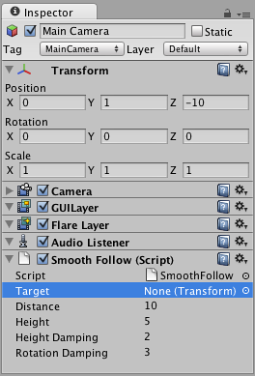

Fig 3.7 Inspector with tranforms

# Other Views

* The [Console](http://docs.unity3d.com/Manual/Console.html) shows logs of messages, warnings, and errors.
* The [Animation View](http://docs.unity3d.com/Manual/AnimationEditorGuide.html) can be used to animate objects in the scene.
* The [Profiler](http://docs.unity3d.com/Manual/Profiler.html) can be used to investigate and find the performance bottle-necks in your game.
* The [Asset Server View](http://docs.unity3d.com/Manual/AssetServer.html) can be used to manage version control of the project using Unity’s Asset Server.
* The [Lightmapping View](http://docs.unity3d.com/Manual/GlobalIllumination.html) can be used to manage lightmaps using Unity’s built-in lightmapping.
* The [Occlusion Culling View](http://docs.unity3d.com/Manual/OcclusionCulling.html) can be used to manage Occlusion Culling for improved performance.

**Scenes:**

Scenes contain the objects of your game. They can be used to create a main menu, individual levels, and anything else. Think of each unique Scene file as a unique level. In each Scene, you will place your environments, obstacles, and decorations, essentially designing and building your game in pieces.

**Prefabs:**

Unity has a Prefab asset type that allows you to store a GameObject object complete with components and properties. The prefab acts as a template from which you can create new object instances in the scene. Any edits made to a prefab asset are immediately reflected in all instances produced from it but you can also override components and settings for each instance individually.

In this game, every letter of the alphabet is an object initially, all of them are placed on the grid made and then, the grid is converted into a prefab. The advantage of this is that we can use the same grid elsewhere too! Next, scripts are written that whenever a string is submitted in the text box, the string is checked for correctness in the database connected to the Engine using ODBC. If it exists and is not found already then the score increases by one.

The timer gives the player a maximum of 100 seconds only. After that, Game over scene is loaded. The game can also be restarted by pressing the pause button on the screen, or in the same pause pane which appears one can go back to the main menu. The initial screen which appears when we start the application is called as the **Splash Screen**. The splash screen initializes everything and since we never return back to the splash screen those settings are not reset again.

Once the game is programmed and tested, it is converted into a .exe file for the PC platform using the build settings, the physics engine compiles it automatically and packages the code into a exe file, but one thing to be sure is that the screen size and resolution should match with the user’s screen size. All this has to be set while coding itself.

**4. RESULTS**



Fig 4.1 Title page in the project with the heading and the names.



Fig 4.2 Beginning scene of the game with a play button



Fig 4.3A scene with all the levels- computers, colors, motorcars, gemstones along with details like how to play, sound on-off and quit buttons on right and links to facebook twitter and google+ on left.

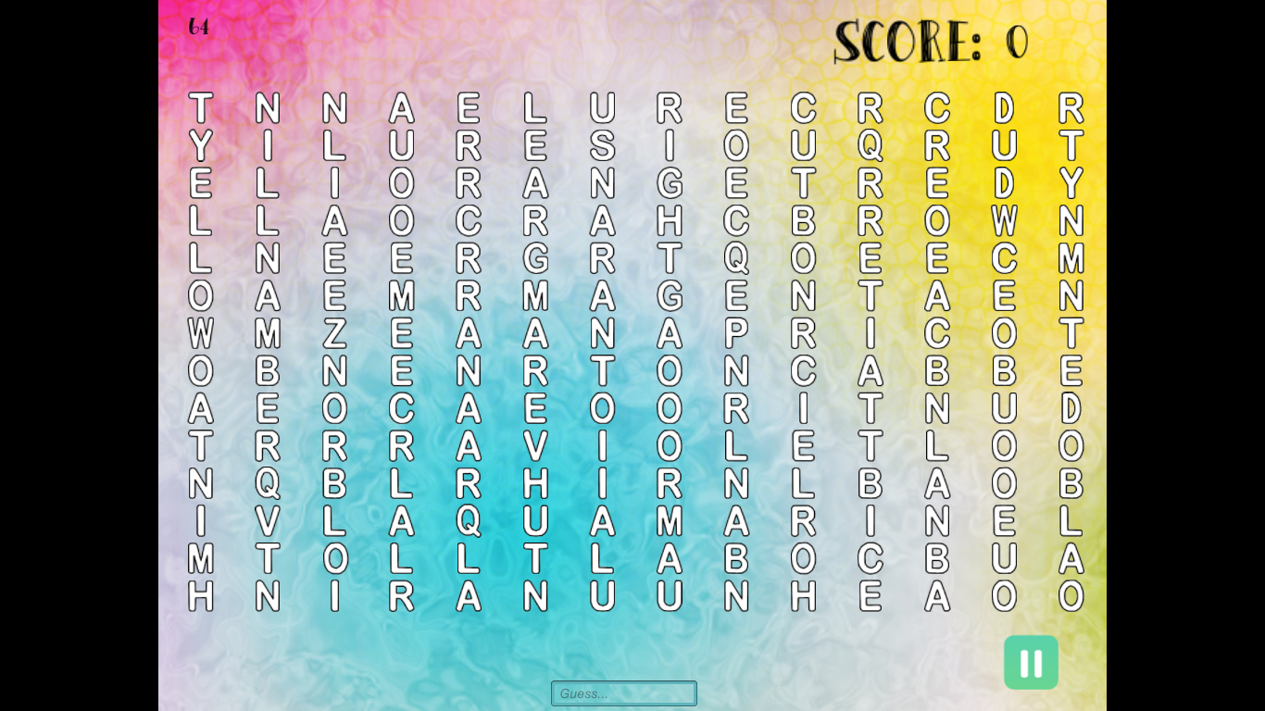

Fig 4.4 A scene showing grid of puzzle colors along with a text box to type in and score on right top. A timer on left top is set to 100 seconds.

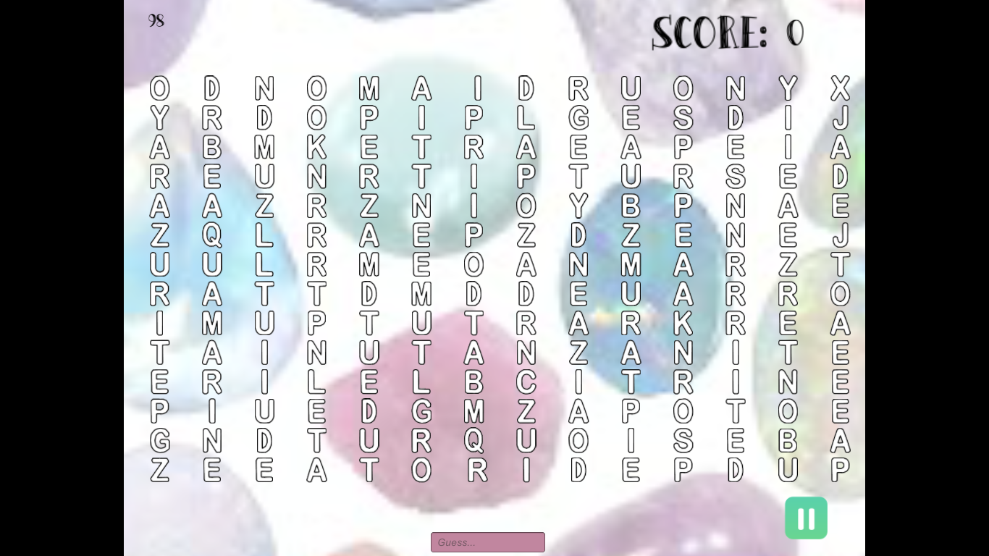

Fig 4.5 A scene showing grid of puzzle gemstones along with a text box to type in and score on right top. A timer on left top is set to 100 seconds.

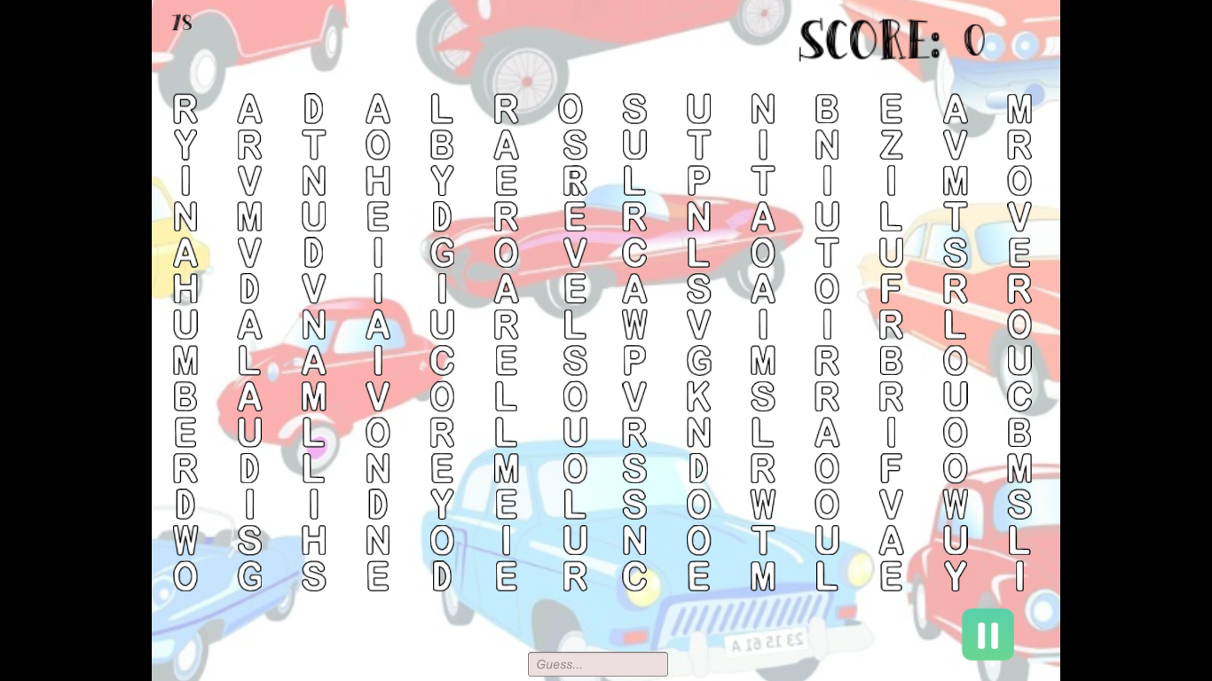

Fig 4.6 A scene showing grid of puzzle motor cars along with a text box to type in and score on right top. A timer on left top is set to 100 seconds.

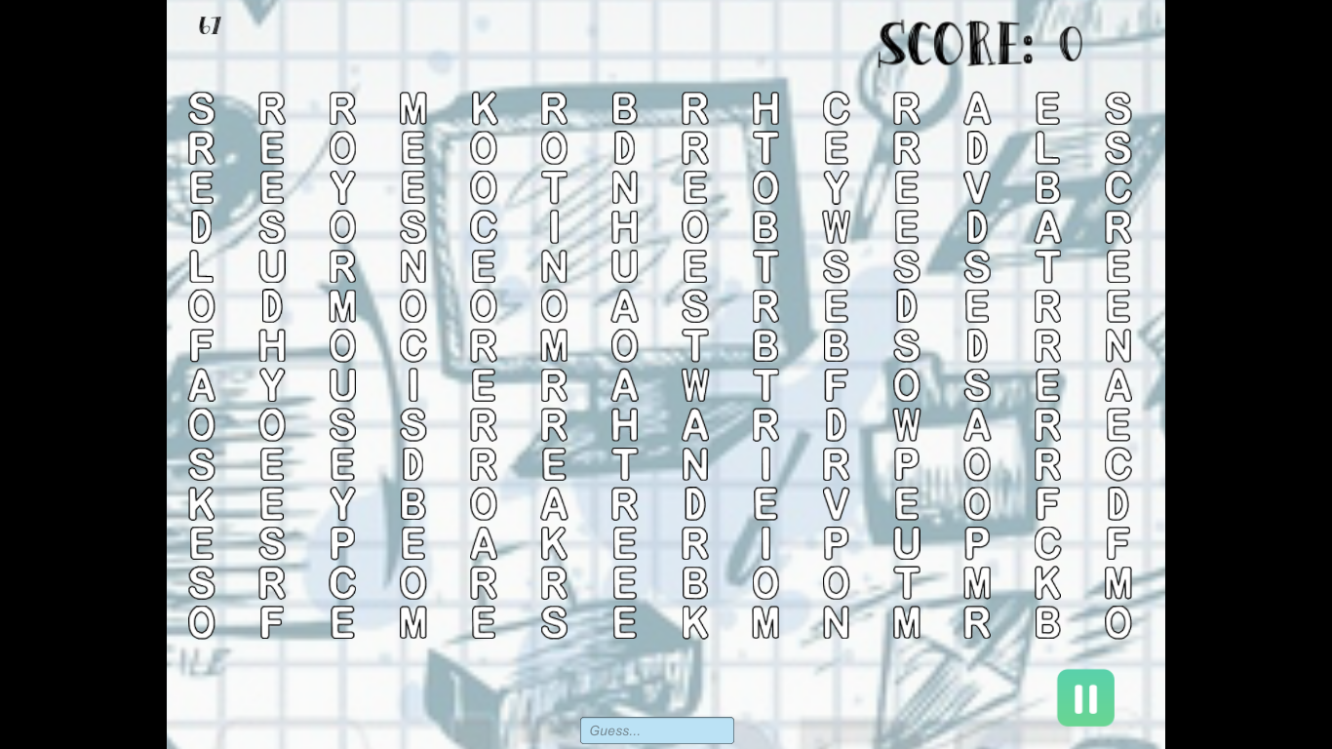

Fig 4.7 A scene showing grid of puzzle computer along with a text box to type in and score on right top. A timer on left top is set to 100 seconds.



Fig 4.8A scene showing the game paused along with play again, restart and home options.

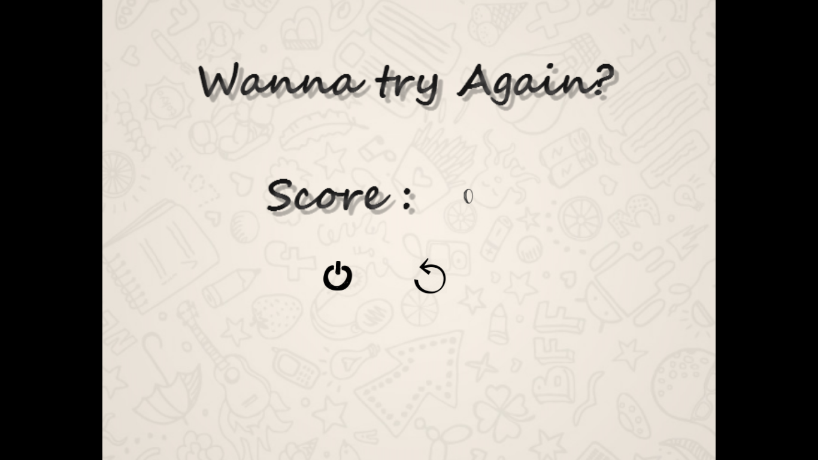

Fig 4.9 Scene describing end of game after the timer stops along with quit and play again options.

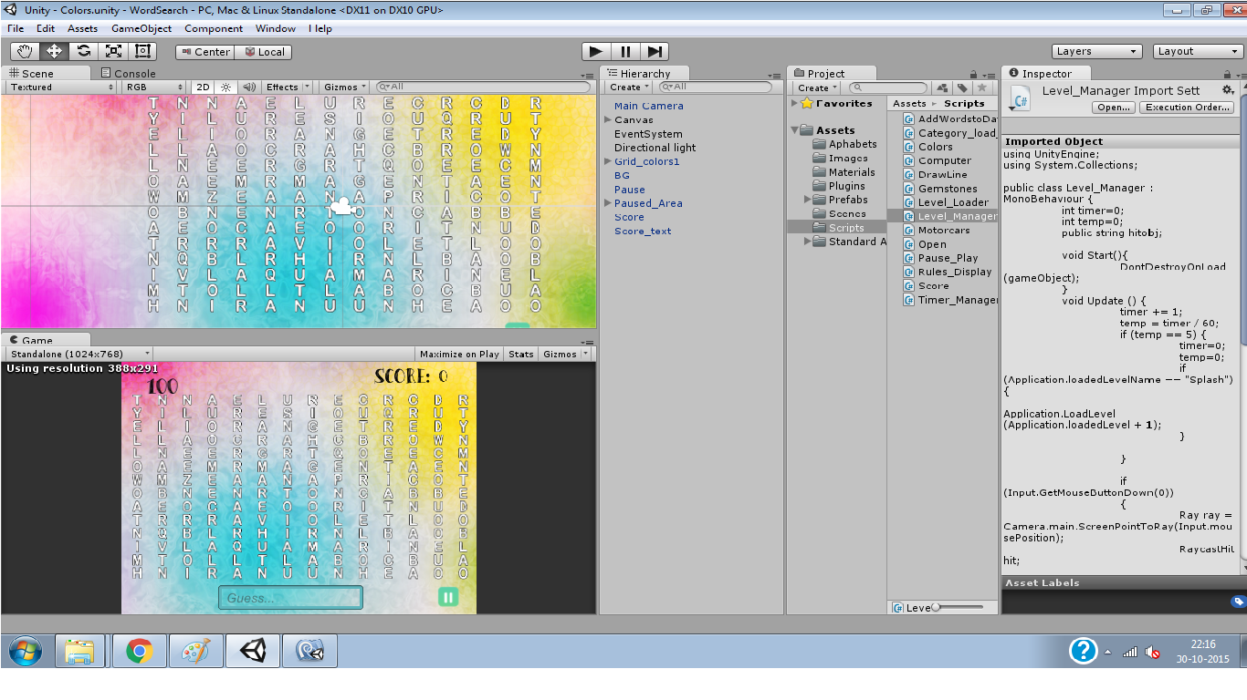

Fig 4.10Scene view as well as Game view of colors grid. On right, hierarchy as well as script are shown.

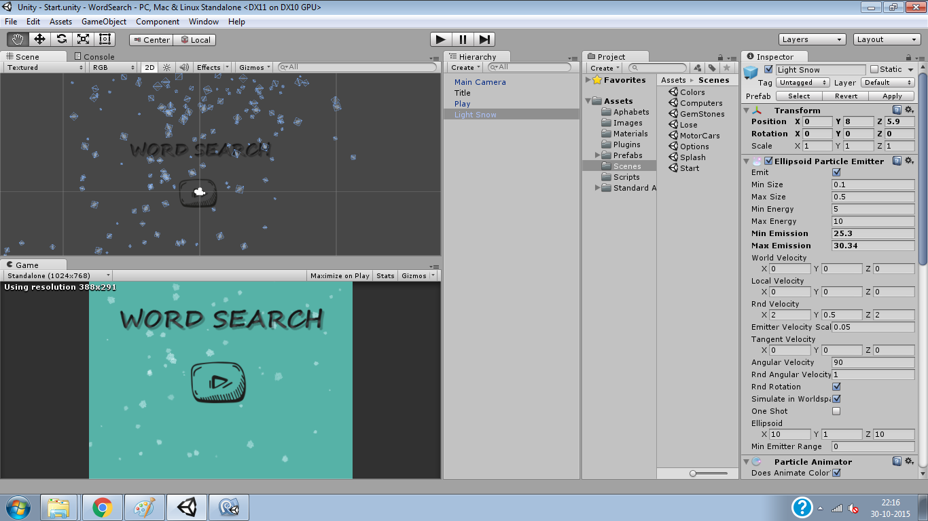

Fig 4.11 A scene showing the foam sprinkling in the background.

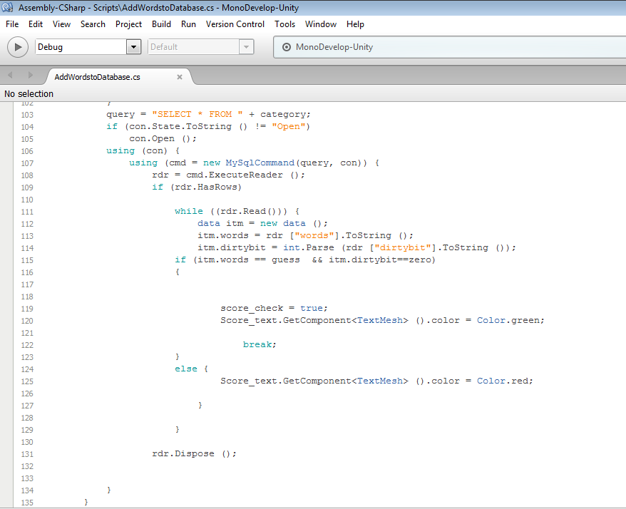

Fig 4.12 A script showing connection of unity to database.

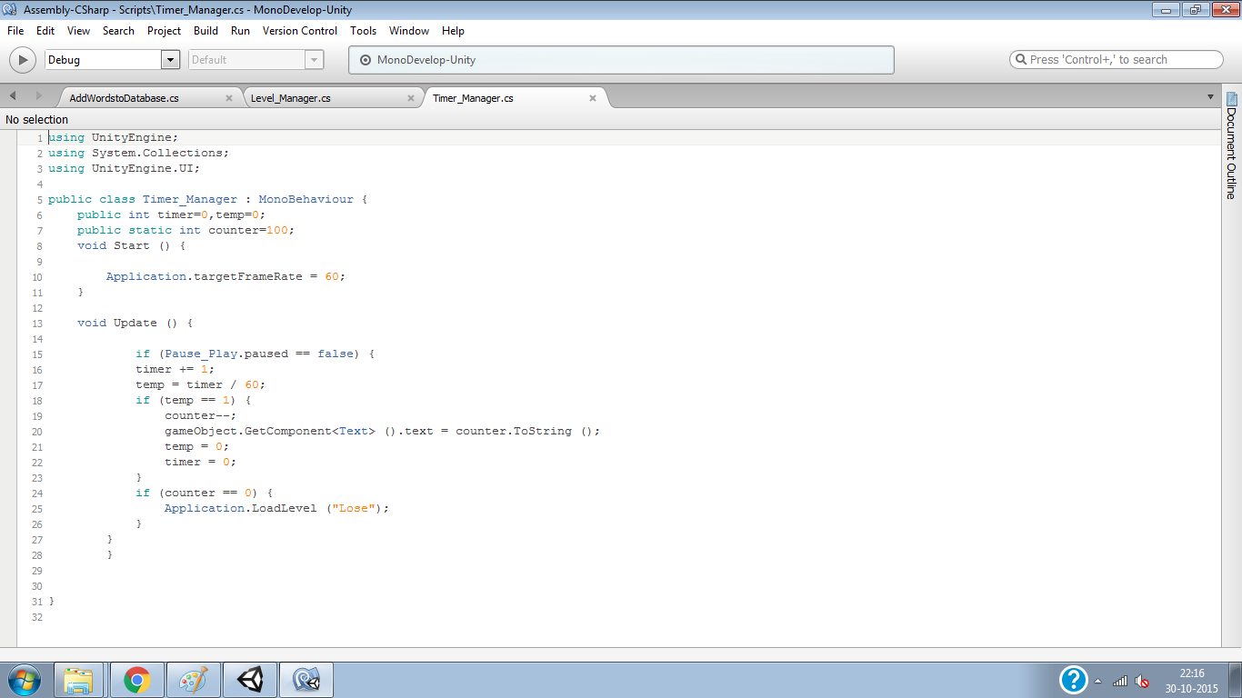

Fig 4.13 A script implementing timer.

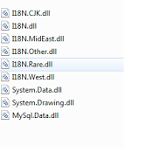

Fig 4.14 A figure showing dll files

\

**5. CONCLUSION**

Word Search is a puzzle that aims at improving vocabulary of the player. More importantly, as the player searches for the words horizontally, vertically and diagonally he is forced to think in all possible ways for a given puzzle which helps in improving his thinking skills. The time limit helps an individual to quicken himself and be competent.

Also, connecting SQL database to Unity opens it up to expand into a multiplayer game where information of each player like his name, scores, and the highest score of his till date can be stored. High end games are impossible to code using traditional programming techniques. So, in this project, we would like to portray how games are actually programmed using a Physics Engine which is actually more or less a simulation of the real world.

**6. FUTURE SCOPE**

The word search game not only improves vocabulary but also proves to be a good exercise for mind. This can be further extended by improving animations during game play. Many more levels can be added to the game and more genres of the puzzles can be incorporated. It can also be developed as a mobile application.

It can be made a multiplayer where a player plays against another and a time limit is kept to decide which player has completed a particular level first. As all the letters in the grid in each level are objects, the game can be further developed into a mobile application where the letters are selected with touch instead of typing in the word. Letters being objects can be enabled such that with a mere touch of a group of letters, a word is formed.

Further, using the similar scripts and animations present in Unity, many more games can be developed.

**7. BIBLOGRAPHY**

* [www.wordsearch.com](http://www.wordsearch.com)
* <http://unity3d.com/get-unity/download/archive>
* <http://www.monodevelop.com/download/>
* <http://dev.mysql.com/downloads/>
* <http://forum.unity3d.com/threads/63008-Connection-to-MySQL-DB-mysql-client-dll>
* <https://www.youtube.com/watch?v=zU_Bpbt8NTE>
* <https://www.youtube.com/watch?v=X7AV7xAvtIs>
* <https://www.youtube.com/watch?v=QoZ0FyRo1DQ>